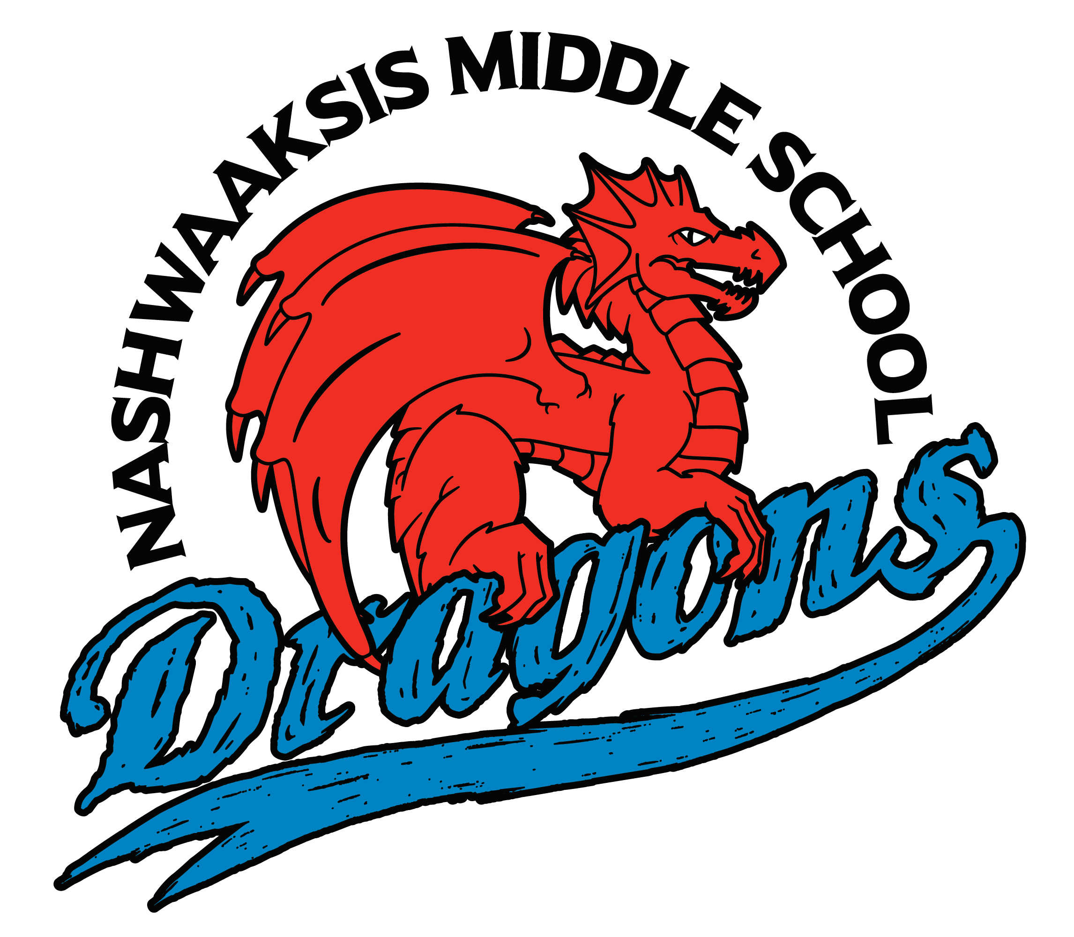

Nashwaaksis Middle School
324 Fulton Avenue, Fredericton, NB E3A 5J4
Phone: (506) 453-5436 FAX: (506) 444-4129

Principal Vice Principal
Kendra Frizzell Marcie Connors

Hello Dragon Families,

NMS PSSC are recruiting you!!!

Did you know that a Parent School Support Committee (PSSC) ensures that the parent voice is heard in setting education priorities and planning for improvements in our school?

The PSSC assists the principal in an advisory role. The committee addresses broad issues related to the education of all children in the school, with the goal of enhancing student learning. Primarily these issues arise from input, discussions, and study of the school improvement plan

This year the committee has unanimously voted to select the Chair for the coming academic year. This would an early transition from one chair to the next and enable swift continuity at the beginning of the next academic year.

The Chair:

• Sets the meeting dates, times, and agenda with the Principal, in consultation with PSSC members,
• Stimulates discussion by asking questions, encouraging quiet members to participate,
• Keeps to the agenda by setting and keeping time limits.
• Helps members reach consensus; calls for a vote if necessary
• Ensures PSSC minutes are maintained and distributed.

Please forward an email to me by end of day May 23, 2022. All interested parties will be contacted, and names brought forward to the entire PSSC committee.

NMS will be hosting an after-school SOCIAL, formerly known as a school dance.
Save the date: May 19th @6:30pm-8:30pm. We are very lucky to be able to host our social in our gym with 3 huge courts. The first court is set up with a volleyball, the second court is set up with chairs and tables to play board games, eat, and chat. The third court is where the “dance” happens. Most kids float between the 3 courts. Please see the next link for more details.

Grade 8 Parents: SAVE THE DATE: Grade 8 Celebration is June 22, 2022

Here is a breakdown of the day:

We are going to celebrate each student (by homeroom) with a certificate in our theatre during the times below. It will be a walk across the stage to accept their certificate and take a second for a picture. You are invited to attend your child’s particular time slot. There are no restrictions to how many family members are invited.

8A: 8:30 – 9:15
8C: 9:15 – 10:00
8D: 10:00 – 10:45 **8D and 8I will have their ceremony time at the same time
8I: 10:00 – 10:45
8E: 11:00 – 11:45
8F: 11:45 – 12:30
8G: 1:00 – 1:45
8H: 1:45 – 2:30

***6:30pm-9pm will be the evening dance in our cafeteria. Most students usually arrive at 6:30pm and take a few pictures out front of the school and enter the school around 6:45pm.

Don’t forget: the fee for Grade 8 Celebration is $26.50 all proceeds go towards making the evening a memorable middle school graduation!

****A few things about the day/evening.
- Only NMS Grade 8 students are invited.
- No particular dress code—except school appropriate. Most students are casual to semi-formal. It is important to note that it gets very hot in the cafeteria with 200 kids…so a suit would be too hot.
- We will have pizza to feed them.

Finally, today was our last day with Chartwell for the school year. Our sweet Ms. Mandy has accepted a new adventure and we were unable to find a replacement. A few of our teachers came together to organize a few hot lunches for next week while we get use to not having a cafeteria. Ms. Shannon sent out a memo (she is quicker and more efficient than me) with the options to buy via Cashless Schools.

